
MINISTRY FOR EDUCATION AND SCIENCE OF RUSSIA
________________________________

SAINT PETERSBURG ELECTROTECHNICAL UNIVERSITY

«LETI»
________________________________

APPROVED
18/03/2021
__________________________
Date, signature

_____________ (( OnMyWay_))_______________________

STATEMENT OF WORK -2-

SOW(2)-18/03/2021

St. Petersburg / Санкт-Петербург

2021

Teacher
Filippov Evgeny Vasilyevich / Филиппов Евгений Васильевич e.philippov.leti@mail.ru
Ерошкин Александр Владимирович
a.eroshkin@sigma-it.ru

content

- History
- Project team
- Key milstones
- What is our project?
- What we need to apply this app?
- Basics of development
- Dart as a language for coding
- Who is interested in this project (stakeholders)
- High level Architecture of our project
- Project goals and vision
- Project risks and problems
- To finish the app in the specific timetable we need

History

 | Date | Short description
SOW -1- | 04/03/2021 | 1-Name of project  2- Idea of project
SOW -2- | 18/03/2021 | - Project Description  - Basics of development  - High level Architecture

Project team

№ | Name | Group | Project role | Contact Information
1 | Bushra Ahmad | 6300 | All application | Bushraahmad407146@gmail.com  +79516522218
2 | Shahrukh Sultan | 6300 | All application | getssultan@gmail.com  +91 8638791167

Key milstones

№ | Start date | End date | Description
1 | 01/03/2021 | 18/03/2021 | Determine the project idea and requirements for its application and prepare the tools for its implementation
2 | 2021/03/21 | 2021/04/22 | Learn the Dart language and write the code for designing the user interface and application
3 | 2021/04/23 | 2021/05/20 | Connecting the application with the server, testing the code, and fully realizing the application
4 | 2021/05/20 | 2021/05/25 | Defense

ON MY WAY

What is our project?

we want to design an Andriod application , this application will help people in transporting, especially in the countries which transporting isn't available a lot in hole day, so this app make people help themselves and this the Purpose of the system

What we need to apply this app?
Andriod studio
Framework
Code language
Server

Basics of development :

the environment for coding (program Android studio)
Framework is flutter:

Why we choice the flutter as a framework?
Flutter is an open source software for a suite of software development tools developed by Google to build user interfaces for Android and iOS system applications.

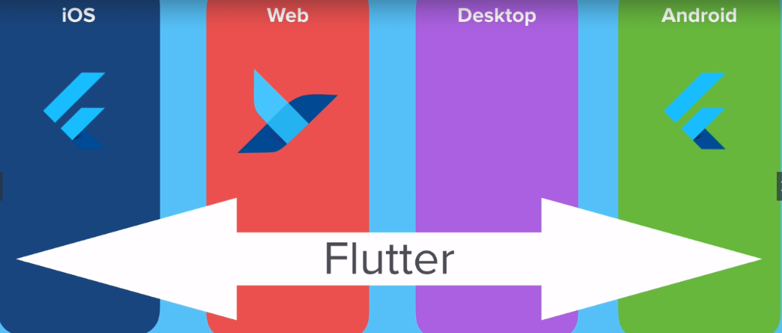

Deal with several screen size

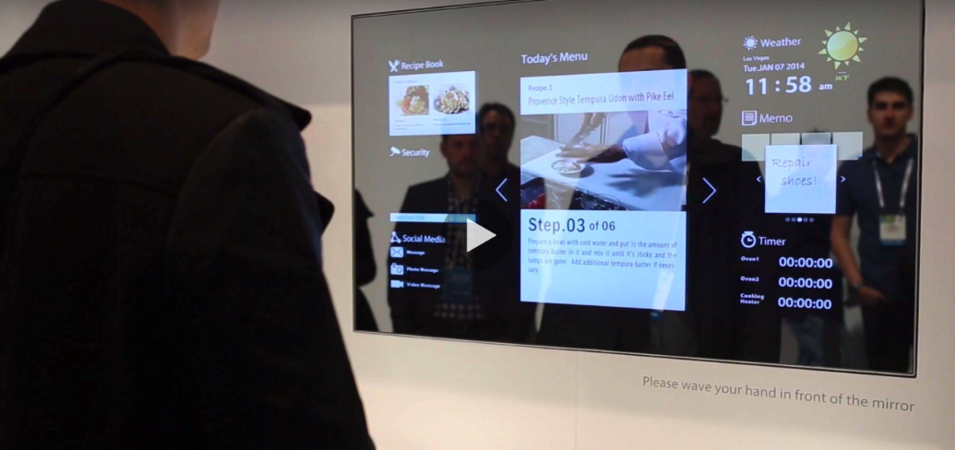

Dart as a language for coding:

1-Ease of learning, You won't waste much time while you are learning it
2-A very flexible language in the sense that you can run it anywhere without any restrictions. You can run Dart applications. For mobile devices on Android - IOS. You can run web applications that you create on any browser
3-Multi-platform.
4-under developing

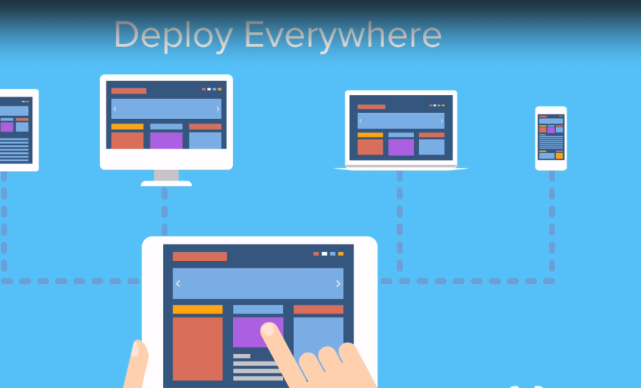

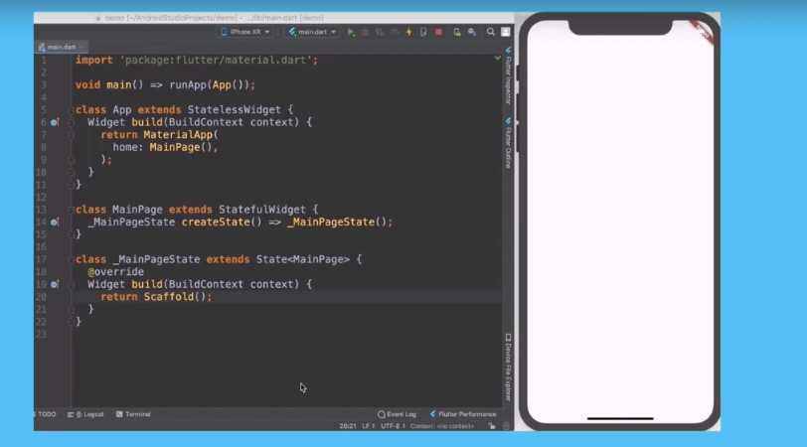

Who is interested in this project (stakeholders) ?
When people have the opportunity to move from one place to another, at a time that suits them, and for free, this is what makes the application the focus of everyone's attention
Many people find great happiness in helping others
the developers of this application when they find a great ability form people to use the application, they may convert it into a business plan and develop it.

High level Architecture of our project :

system requirements

user
Application
Using
Flutter
Dart

Android
+
IOS

API Server
Web request
Contain UI

Server :

Sql Server
Installed
Database

ASP.net
famework
post
get

http protocol

Project goals and vision

Actually there are two important goals to us from this application :
1- let people helping themselves by this type of application.
2- maybe this project isn’t a big project but this subject in this semester will be the first step in software developing world for us so when we apply this application and every thing is ok that mean a lot for us.
3-By developing it over the days, it becomes a business plan for us.

Project risks and problems :

I think we will find some problems when we want to export the code from windows because ios systems need export from Mac but we solved it by Virtual system installation
Some problems with server maybe.

To finish the app in the specific timetable we need

Three hours every day, five days a week

